# Department of Computing

**CS471: Machine Learning**

**Class: BESE-7AB**

**Lab 5: Artificial Neural Network**

**Date: 22-02-2019**

**Time: 10:00 am– 1:00 pm & 2:00 pm-5:00 pm**

**Instructor: Dr. Pakeeza Akram**

**Name: Nimra**

**Class:BESE-7B**

**Reg No.199281**

**Lab 10: Artificial Neural Network**

**Tasks**

Develop your own ANN

* **Iamtrask code for basic ANN development**

**Code**

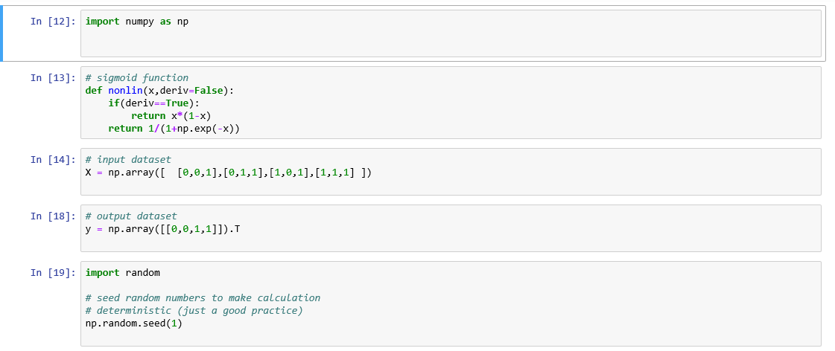

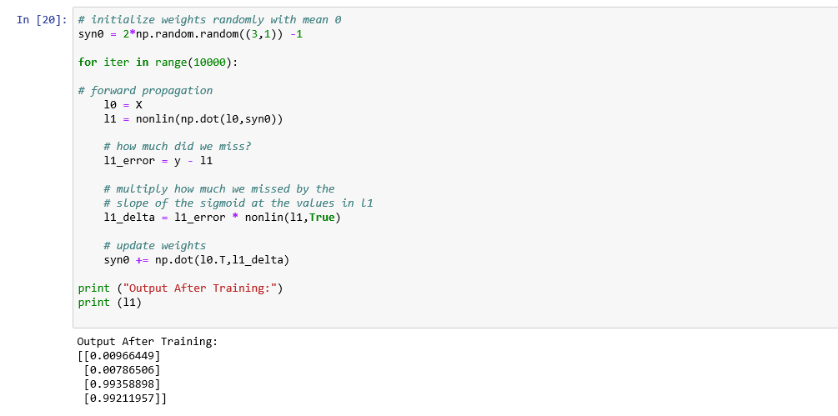

* **Change the number of layers and neurons**

**Code:**

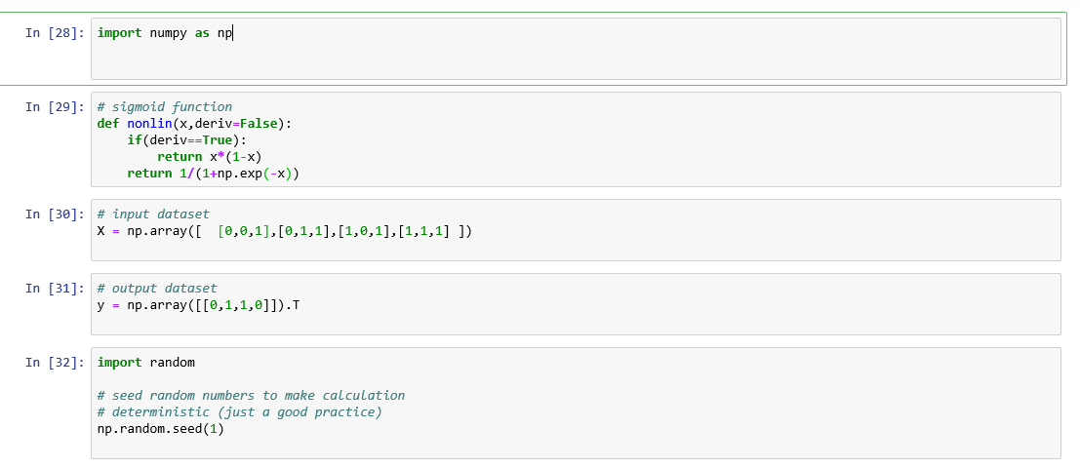

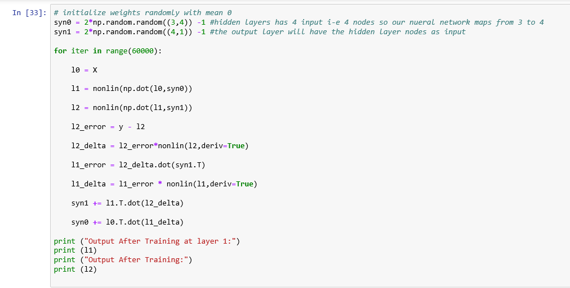

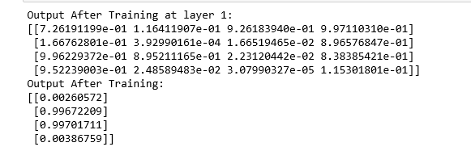

* **Multi-class classification**

**Code:**

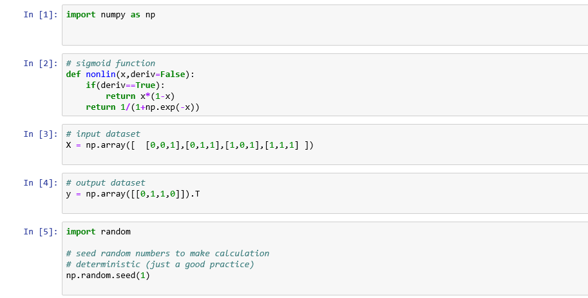

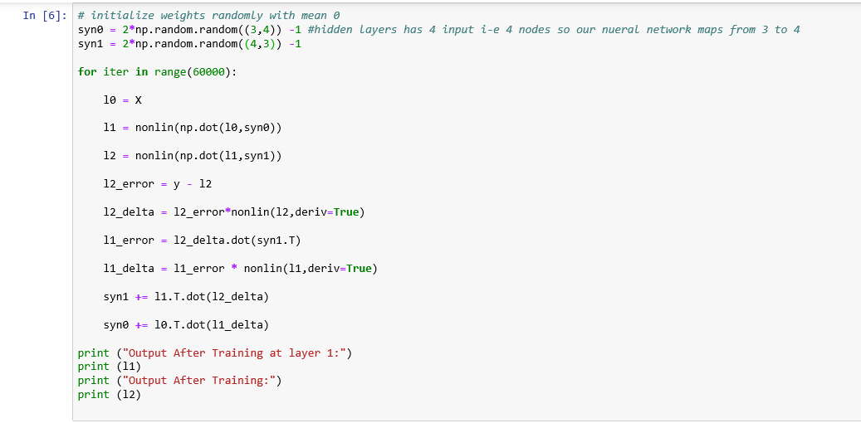

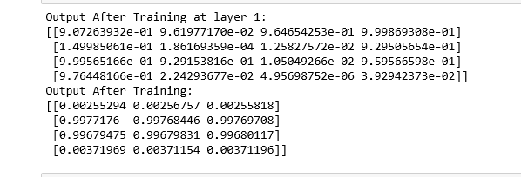

* **Regression function by using different layers as regressors rather than logreg.**

**Code:**

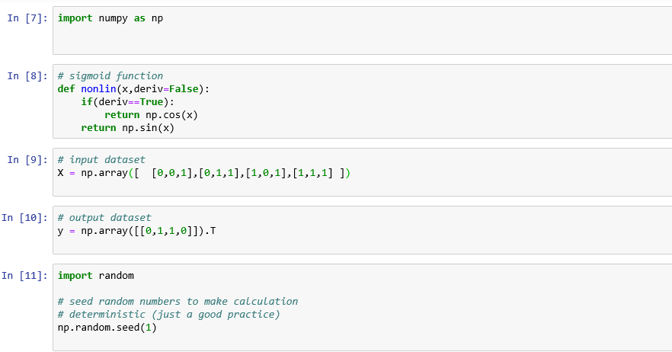

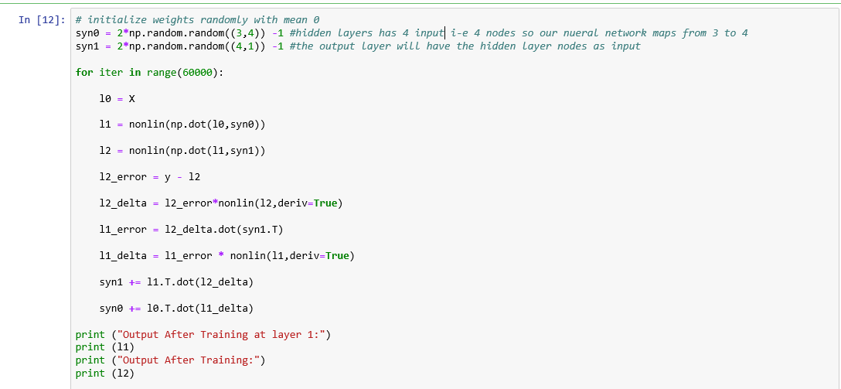

**Output**

